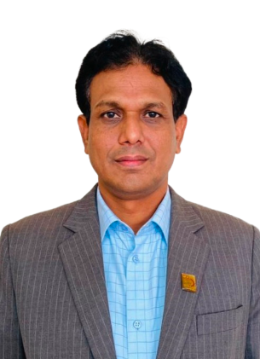
Biography of Engr. Md. Jahangir Alam
(Additional Director)

Mr. Jahangir Alam, is an experienced professional in the field of engineering and management, currently holds the valued position of Additional Director at Tool and Technology Institute (TTI), Bangladesh Industrial Technical Assistance Center (BITAC) under Ministry of Industries, where dedication and expertise converge to shape the future of technology and innovation. He embarked on this remarkable journey in 2003, commencing as an Assistant Engineer at BITAC. Armed with having a B.Sc. in Mechanical Engineering in 1996 from Rajshahi University of Engineering and Technology (RUET), he provided a solid technical background. It wasn't long before he expanded his horizons by earning an MBA in Finance in 2011, adding a strategic dimension to his skill set.
The early years he has made significant contributions as an Executive Engineer at BITAC Chattogram from 2003 to 2017. He took charge of crucial departments such as the Machine Shop, Tool Shop, Production Control Department, and Industrial Engineering Department (Marketing), that provided the fastest marks on the organization. During his leadership in BITAC Chattogram different government and non-government organization such as fertilizer industries, chemical industries, Power Development Board, steel mills, various engineering sectors got services from BITAC Chattogram.
In 2017, Mr. Jahangir took on the role of Center Head and Additional Director in BITAC Chandpur, showing his leadership penetration. The next chapter unfolded in his career when he holds the position of Additional Director of TTI in 2023. In this capacity, he oversees the Training Division, Research and Development, and Entrepreneurship initiatives, steering the organization towards new heights of excellence.
Mr. Jahangir’s commitment to continuous improvement is evident in his diverse training portfolio, covering areas such as Total Quality Management (TQM), Welding Technology, Material and Metallurgical Engineering (MME), Project Planning Management (PPM), and eGP system. These experiences have not only enhanced his technical expertise but have also equipped him with a full understanding of the industry. The story of Mr. Jahangir is a testimony to the power of passion, education, and unwavering dedication in the pursuit of excellence.

